DATA SPLIT UP AND CROSS VALIDATION

AIM
To split a dataset into training and testing sets using the train_test_split() function from the Scikit-learn library, with 80% of the data used for training and 20% used for testing.

ALGORITHM
- Import the Pandas library and train_test_split from Scikit-learn.
- Load the dataset from the CSV file data.csv.
- Select the input features: Hours_Studied, Attendance, and Assignments.
- Select the target variable Result as the output.
- Split the dataset into training and testing sets using train_test_split().
- Set test_size=0.2 to allocate 20% of the data for testing.
- Set random_state=42 to ensure reproducible results.
- Display the training and testing datasets.
- Print the number of training and testing samples.

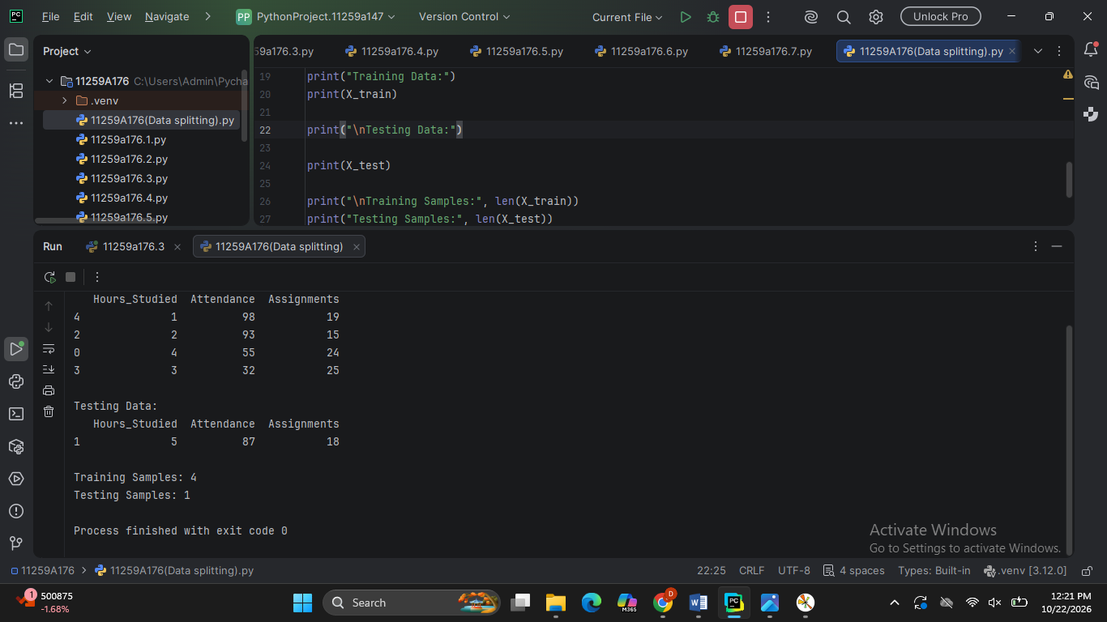

RESULT
The dataset was successfully divided into training and testing sets using the train_test_split() function. Approximately 80% of the samples were allocated for training the machine learning model, and 20% were allocated for testing its performance. The exact number of samples depends on the size of the input dataset.

AIM
To evaluate the performance of a K-Nearest Neighbors (KNN) classification model using 3-fold cross-validation and calculate its average accuracy.

ALGORITHM
- Import the Pandas library and the required functions from Scikit-learn.
- Load the dataset from the CSV file data.csv.
- Select the input features: Hours_Studied, Attendance, and Assignments.
- Select the target variable Result.
- Split the dataset into training and testing sets using train_test_split(), with 80% for training and 20% for testing.
- Display the number of training and testing samples.
- Create a KNN classifier using KNeighborsClassifier(n_neighbors=3).
- Perform 3-fold cross-validation using cross_val_score() with cv=3.
- Display the cross-validation accuracy scores.
- Calculate and display the average accuracy using scores.mean().

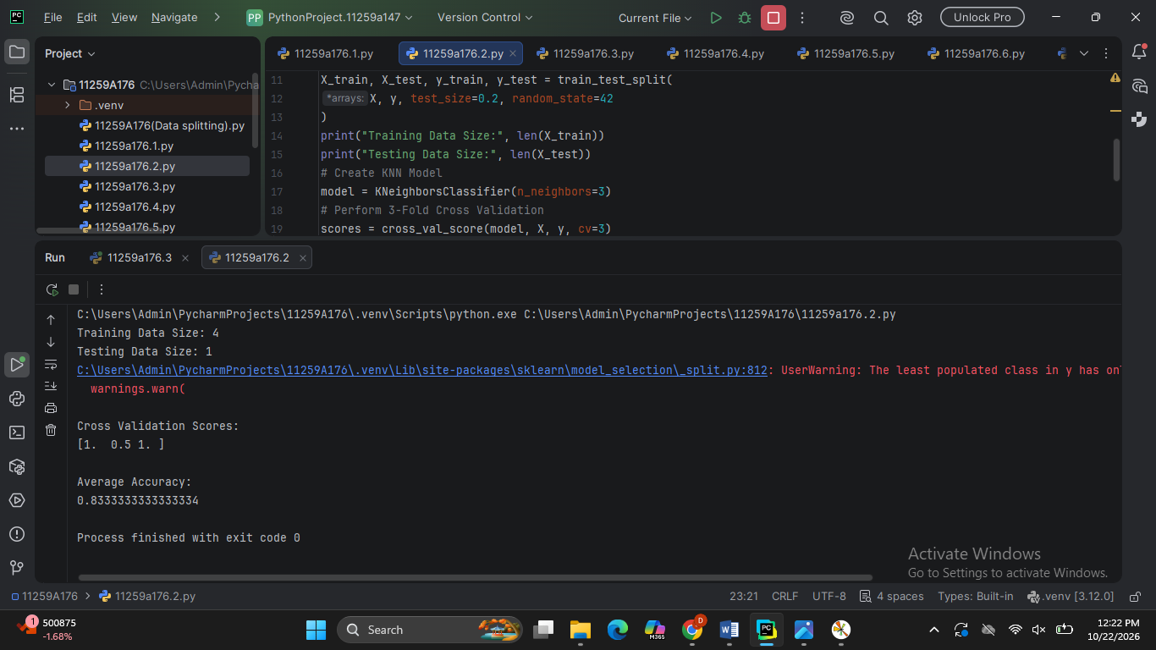

RESULT
The dataset was successfully divided into training and testing sets, and a KNN classifier with K=3K=3 was evaluated using 3-fold cross-validation. The individual cross-validation scores and average accuracy were calculated and displayed.
The actual accuracy values depend on the dataset in data.csv.

